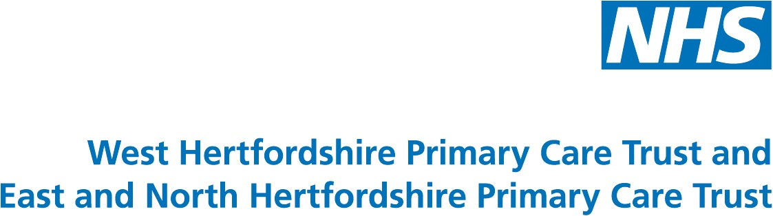

Charter House
Parkway
Welwyn Garden City
Hertfordshire
AL8 6JL

12 December 2006

Dear Colleague

Serious Financial Position

We are writing to bring you up to date with the serious financial position faced by the NHS in Hertfordshire.

The financial recovery plans drawn up by the former Hertfordshire PCTs have not delivered all the savings required and we now have to make further savings during the last four months of the year.

We know that you have already achieved significant reductions in unnecessary secondary care referrals and in improving your prescribing practice.

We require your help to implement further measures to bridge the financial gap. Failure to do so will mean that our financial allocation in 2007/2008 will be reduced and we will face another year of extreme financial difficulty and uncertainty.

Some of the measures needed are solely within the control of PCTs but many require the co-operation of our secondary care providers. We are working closely with the Chief Executives of the Hertfordshire Acute Trusts and the Mental Health Trust to deliver savings.

The two PCTs are exceeding, by a significant amount, the activity set out in the service level agreements we have with more than 30 NHS trusts. Therefore, we have directed all providers of acute services to treat only patients whose conditions are urgent or who are at risk of exceeding the 20 week maximum waiting time. Similar guidelines are being applied to patients waiting for outpatient appointments or diagnostic tests.

Your continued help is needed in the following areas:

- Referrals

This is an area where we could achieve the greatest savings. Wherever possible and only if you feel it is clinically safe, we would ask you to keep referrals to an absolute minimum. When you need to make a referral we would ask that you ensure the clearly that the referral is clearly marked urgent or routine to ensure proper management and that you do not ask providers to expedite treatment unless absolutely necessary.

- Limited Benefit Interventions

It is particularly important to ensure that patients are not referred for
treatments that have limited clinical benefits. Local guidance can be found on http://www.bhprioritiesforum.nhs.uk/, covering in particular, patients who might be considered for removal of tonsils, insertion of grommets, treatment of varicose veins or any cosmetic surgery as well as other treatments. Where such a referrals are made, please use the agreed templates or ensure that letters clearly state why a patient should be considered exceptional, referring to the guidance. The PCTs’ main websites contain guidance and criteria for referral for IVF treatment.

We have already instructed local NHS providers that payment will only be made for these procedures if prior approval is given. This includes all NHS and non-NHS primary and secondary care providers.

- Prescribing

Using national data the PCTs’ medicines management team has identified a number of areas where there is potential for further reductions in prescribing expenditure. Different parts of the PCTs appear to have significantly different practice in a number of prescribing areas.

Two areas which would appear to be areas for change and have the least impact on patients are statin switching and 28 day prescribing. Our figures show that if all practices achieved optimum levels, annual savings would be over £3 million across Hertfordshire. However, we recognise practices may wish to consider making the equivalent savings in a different way. The PCTs’ pharmaceutical advisors are available to support you in this work.

- Other areas

We are examining all areas of activity including the PCTs’ provider services and HQ as part of the urgent review of all budgets and will be making additional savings in these areas.

We appreciate that these are not easy things to do but we know you recognise the importance of ensuring we tackle and resolve the financial problems to ensure we get best value for patients.

Thank you for your help.

Yours sincerely,

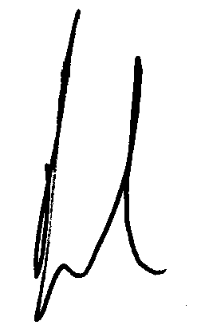
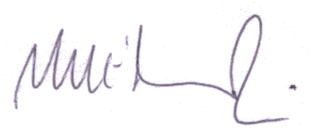

Mike Edwards Jane Halpin Tony Kostick
PEC Chair Director of Public Health PEC Chair
West Herts PCT Hertfordshire PCTs East and North Herts PCT

